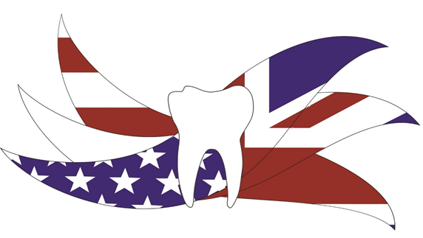
Anglo American Dental Conference: Social and medical influences on dentistry 18th -20th century
REGISTRATION FORM

A conference organised by the Lindsay Society for the History of Dentistry
Saturday and Sunday 8-9th October 2016

Thank you for registering to attend the Lindsay Society for the History of Dentistry Anglo American Dental History Conference 2016.
If you have any queries about registration or the event itself, please email Brian Williams or Rachel Bairsto email brianwilliams14@btinternet.com or museum@bda.org

The deadline for registration is 30TH SEPTEMBER. To take advantage of a reduced ‘early bird’ registration please register by 30TH JUNE

FOR PAPER REGISTRATION FORM – TO PRINT THIS FORM CLICK ON “FILE” AT THE TOP LEFT HAND CORNER OF THE SCREEN AND “PRINT”:
Please complete the form below and return with the appropriate sterling cheque to :
Brian Williams: Hon Secretary Lindsay Society
British Dental Association Museum
64 Wimpole Street
London
W1G 8YS
UNITED KINGDOM

FOR ELECTRONIC FORM CLICK ON “FILE” AT THE TOP LEFT HAND CORNER OF THE SCREEN AND “SAVE AS”:

Please complete the form and make the appropriate electronic payment below.

E-mail the form to brianwilliams14@btinternet.com.

DELEGATE DETAILS (Separate form for each delegate)
NO FORM REQUIRED FOR ACCOMPANYING PERSONS

Title | First name(s) | Last name
Organisation or institutional affiliation

Position

Please indicate here exactly how you want your name to appear on your delegate badge

ADDRESS & CONTACT DETAILS

Address line 1

Address line 2

Address line 3

Town/city | County | Postcode
Email address | Telephone number | Mobile number

Please indicate by ticking the appropriate box below if you are willing for your name, position, organization and email address to be included in the delegate list, which will be distributed to all attendees. Leave both boxes blank if you do not wish your details to be made available in this way to other colloquium participants.

 | I am happy for my name, position and organization to be added to the delegate list |  | I am happy for my email address to be added to the delegate list

MEALS
The registration fee for the Symposium includes morning coffee, light lunch and afternoon tea.
Please indicate any particular dietary requirements below.

Dietary requirements ………………………………………………………………………………………………………………………………………

REGISTRATION
A discounted early bird rate is available for registrations received on or before 30th June.
For further details of the conference please see the full conference itinerary sheet.

Delegate category | Two-day Registration | Number of persons | Total Cost
Early bird price before 30th June | £180.00
Standard price from 1st July | £210.00
Optional outing to the London Eye – Saturday 8th October | £35.00 per person
Friday night – Reception at the Royal College of Surgeons | £35.00 per guest (Delegates free) | Incl delegate
Total Amount: |  |  | £

PAYMENT
Payments can be made by UK cheques and enclosed with this form or electronically. Please complete the section below by ticking the appropriate box to indicate your payment method

☐Enclosed is a cheque made payable to Lindsay Society.
Return to Brian Williams. Hon Secretary Lindsay Society. British Dental Association Museum, 64 Wimpole Street, London. W1G 8YS.

☐Payment by electronic inter-bank transfer
Return the completed downloaded form to brianwilliams14@btinternet.com

Name of guest or accompanying person/s (if applicable):
TITLE | FIRST NAME | SURNAME
1.
2.

Date

PLEASE NOTE THAT REGISTRATIONS FOR THE CONFERENCE WILL ONLY BE ACCEPTED IF SUBMITTED USING THIS FORM.

ADMINISTRATION USE ONLY

Passed for payment | Confirmation sent | Notes

